1- The end in mind ( The goal of the product )
To light the UV bulb with motion momentary .
2- Components of the product .
1- Regulator Metal 7805 which can bare up to 24 Volts
This component is placed right at the Top of the PCB
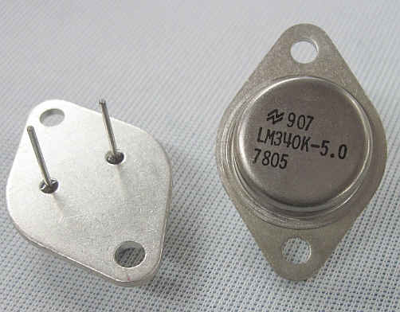

2- Resistors ( choose the right color code that fits for the Resistors values )
In this project 2 resistors 330 ohm and 1 resistor 10k ohm are used .
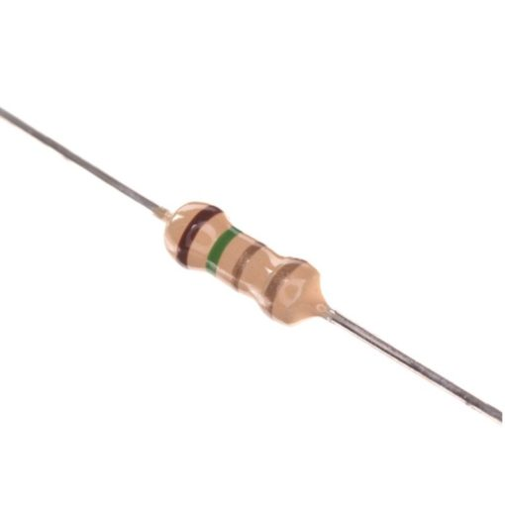

3- Pinheaders Male
3 pinheaders male are used
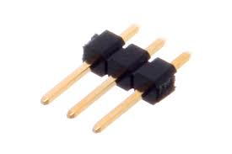

4- XT60 Connector
Only one connector is used male & female
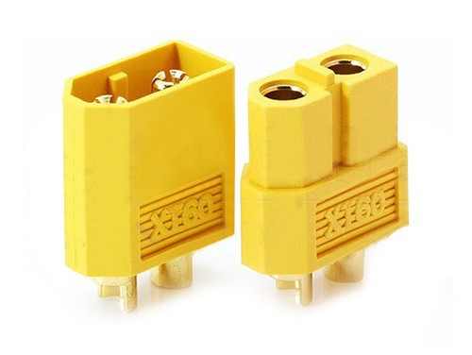

5- Jack Adapter
We will use the female on the Board and the male to connect the DC source
if 24 volts adapter is used then no need for the jack male as it comes along with it .
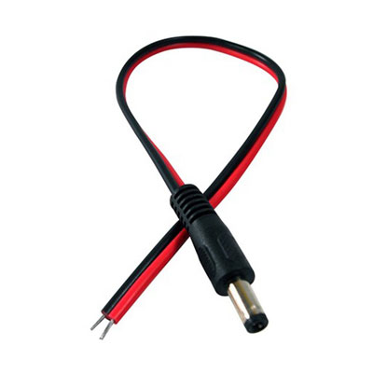
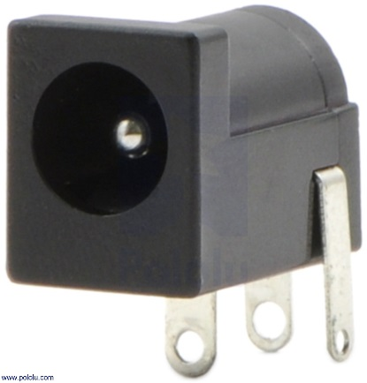

6- Green led 5mm
only 1 led needed for indication

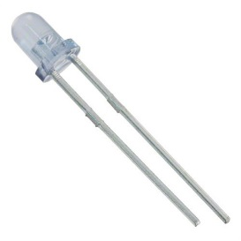

7- Wires
For Ac wires taken from the pushbutton to the XT60 Connector you can choose any wires available , for the Data cables used the 3 pin Data cables shown below

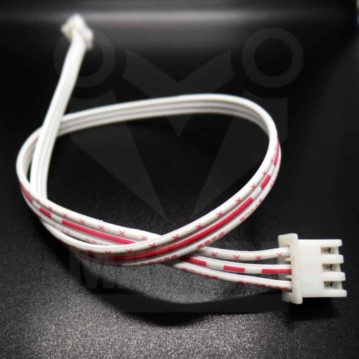
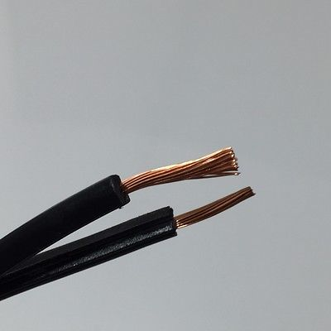

8- Tip 120 Darligton Transistor
The transistor is as shown below only 1 is used
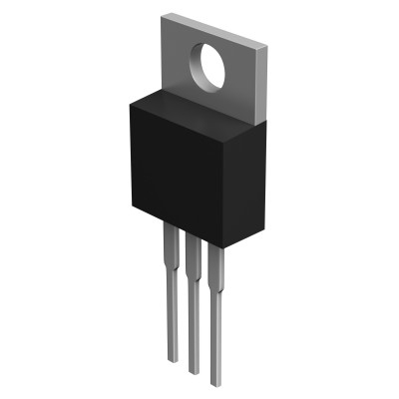

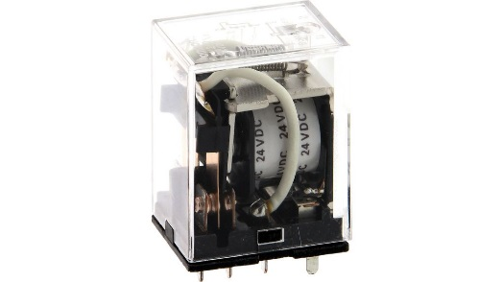
9- Relay Ly20
You can use this Relay or any other Relay available in your country but you'll need to change the footprint 1 relay is needed.

11 - 11W UV lamp
11v UV lamp with it's adapter
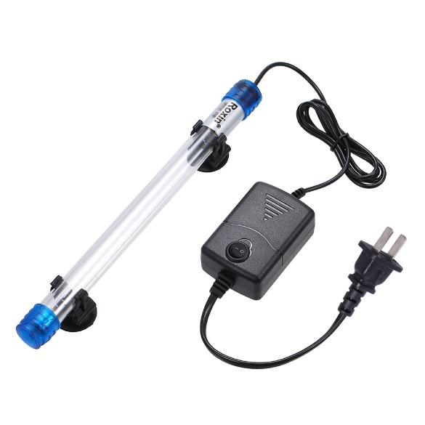

12- 24V DC source
We need 24V DC source to control the Relay Coil and the power of the sensor .
24 volt adapter can be used or any 24v dc source available
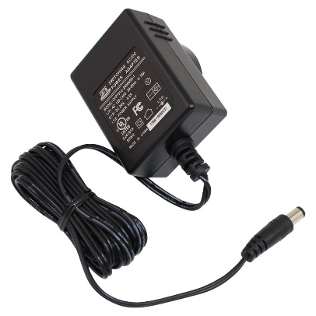

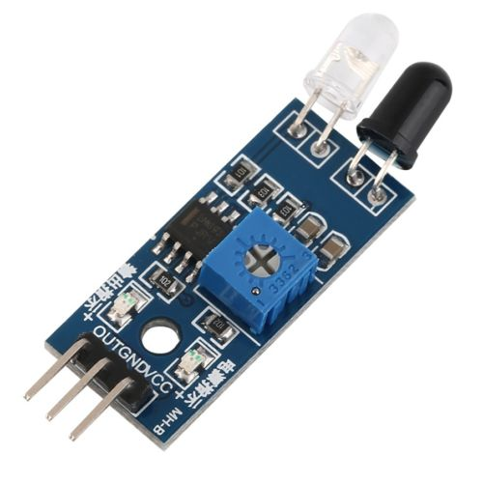
13- Obstacle Sensor

3- Steps for wiring
after recognizing the components then comes the steps of combining all together .

1- First the PCB is soldered with components as shown below
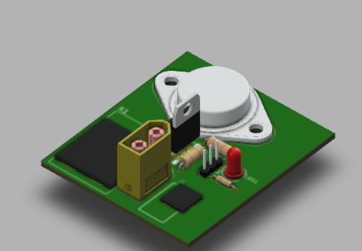

The big black block on the left refers to the Relay , and the block on the right refers to the Jack adapter .
2- after the PCB is done then comes the wiring ,
The UV adapter is opened and the two wires connected to the Switch should be removed and connected to the Female part of the XT60 connector and connected to the male XT60 connector on the board (For safety)
3- The 24 volt DC adapter is then connected to the jack adapter on the board
4- The 3 pin-headers on the PCB are connected to the 3 pin Data cable and from the other end the sensor is connected .
5- adjust the sensitivity of the sensor by manipulating the Trimmer shown on the Sensor

4- How it Works
Once any obstacle goes infront of the Obstacle Sensor it'll give a signal to the Tip120 Transistor .
The Transistor will be Active and the current will flow through the coil of the Relay .
The relay will connect the UV Adapter switch wires and the UV lamp will turn on .
Once the obstacle infront of the Sensor is removed it won't send a signal to the Tip so the device will be Off until an obstacle shows infront of the Sensor .
5- Power sources
The 24 Volt adapter is powered from Ac source and it will power the coil of the Relay .
The Regulator will step down the dc voltage to 5 Volts to power the Sensor .
The UV lamp adapter is powered from Ac source .
Note
If any component doesn't exist in your country change it but also change the footprint in the PCB design so it can fit .

